Quick notes:
- Do not indent as you type.
- Make all chapter headings, “heading 1” font, which can be modified to whatever you like.
- Yes, Kindle supports text boxes, images, and fonts outside of Times New Roman, Calibri, and Garamond
- Do not add page numbers.
- Remove all headers and footers.
- Title and author name should be center on cover page.
- Your book cover is uploaded separately
- Insert page breaks after Cover page, dedication, preface, prologue, copyright, foreword, and at the end of EVERY chapter
- Font doesn’t need to be too big, since Kindle users can change the font size from their device.
- The margins do not matter. Your document can remain 8.5X11

Table of contents:
Once your chapter titles are set to “heading 1” Word can automatically identify your chapters. You will have to bookmark your Table of contents. Simply type out “Table of Contents, highlight, and go to the insert tab, where you will find bookmark. This screen will appear:
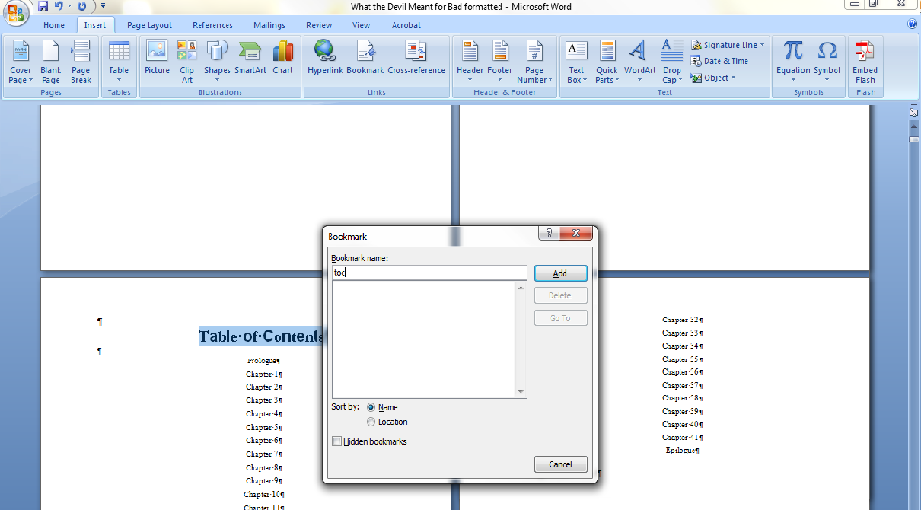
In a name for you TOC and select add. You’re done.
To insert the physical table, go to the references table and select Table of contents. Scroll to insert table.
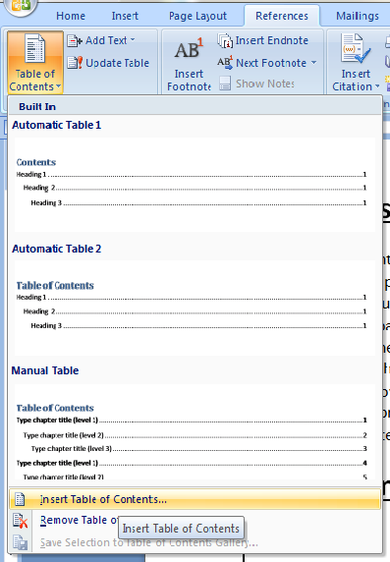
Kindle does not support page numbers. They create their own location from your TOC. A box will appear once “Insert Table of Contents is selected. Your settings should appear exactly like this:
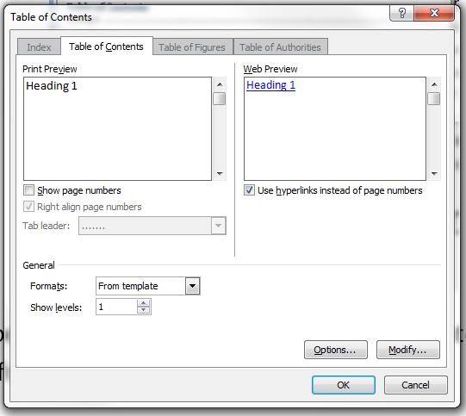
Select ok. You’re done. Fonts on your table can be set whatever what you like. If you add more chapters later, make sure they are heading one as well and under the reference tab, simply select “update table.”

Indenting:
Use this method to add indentions to your Kindle book. Hitting the enter key and using tab to indent can create unwanted spaces in your kindle book. Spaces will ruin the entire format and it will not appear on Kindle the way it looks on your word document.
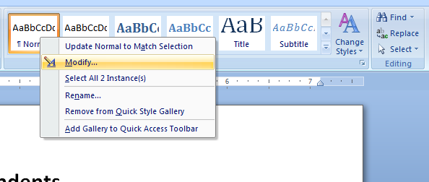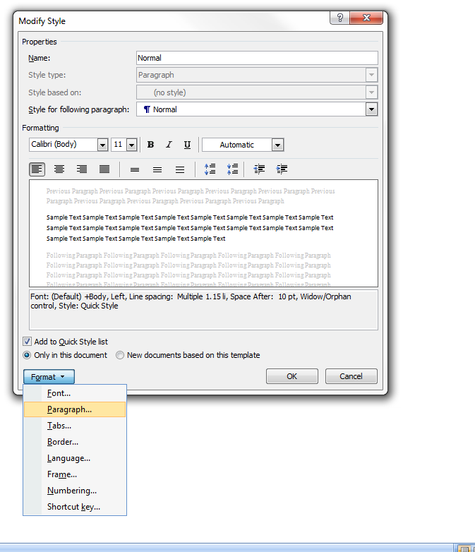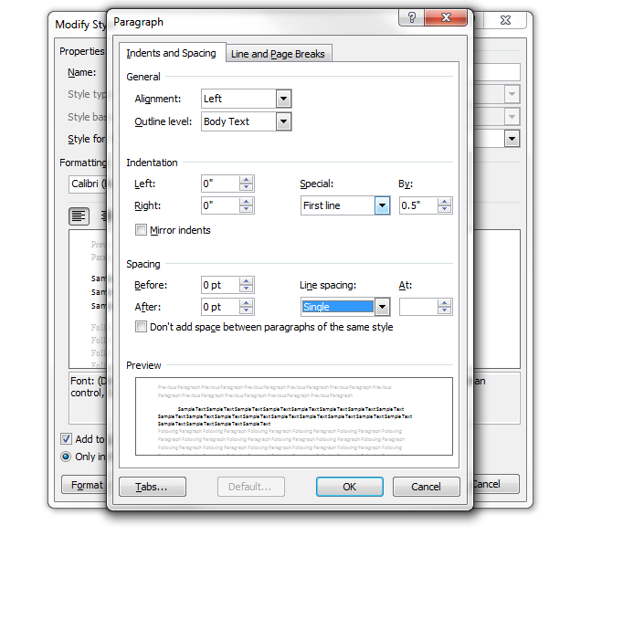

Formatting:
To avoid unwanted spaces and lines use the show/hide key:
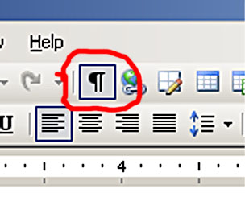
Insert your page breaks found under the “insert” tab. Remove all unwanted spaces.
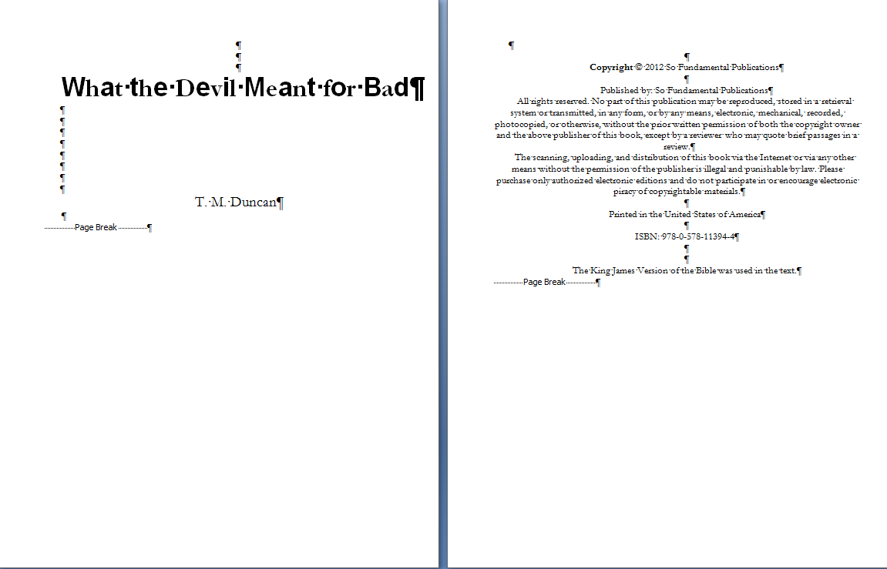

Uploading:
Convert your Manuscript to HTML. Save your document as “Filtered HTML document” on your computer at a location you can easily find it. Select file, save as, webpage, filtered:
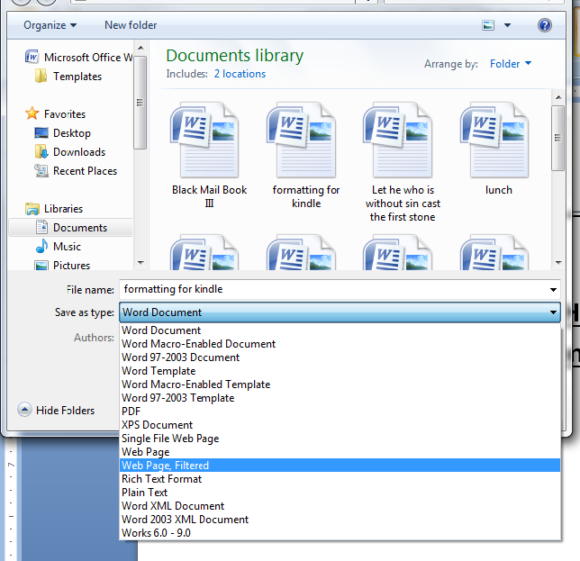

Books with Images:
If your book as images you will need to upload a compressed file/ zipped folder.
In the folder where your saved document is, you will find two files with the name you used: a folder containing images and an HTML file containing your book. Right click on the HTML containing your book and select send to. Then select “Compressed (zipped) folder”.
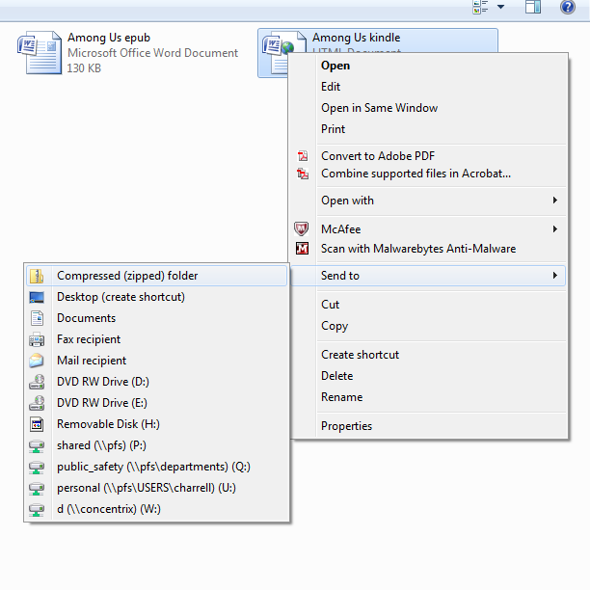
A new folder will appear with the same name and a zipper. Drag the folder with you images into.
That will be the folder you upload to Kindle.

